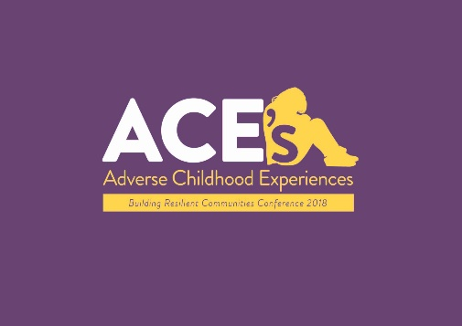
Please complete your details below and tick which event/s you wish you attend and return to Bronagh.donnelly@westerntrust.hscni.net by Monday 11th February at 5pm

NAME:
ORGANISATION:
EMAIL:
DIETRY REQUIREMENTS:
DO YOU REQUIRE ANY ADDITIOANL SUPPORT:

*Please note that the Trauma Informed Organisation workshops are aimed at those middle/senior managers and leaders and champions of ACE’s and Trauma Informed Practice within organisations.
Event | Date | Venue | Attending
Understanding Trauma | Monday 18th February | Fermanagh House, Enniskillen
Trauma Informed Organisations | Tuesday 19th February | Silverbirch Hotel, Omagh
Understanding Trauma | Wednesday 20th February | Fir Tress Hotel, Strabane
Trauma Informed Organisations | Thursday 21st February | City Hotel, Derry

Please note places will be allocated following the closing date for applications and an email sent to confirm your place. As places are very limited if you are successful in securing place and can no longer go please let Bronagh know so that the place can be re allocated.

