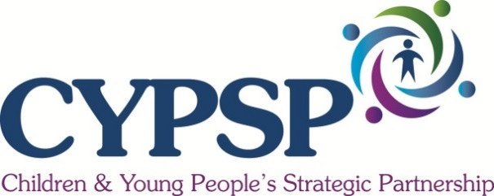
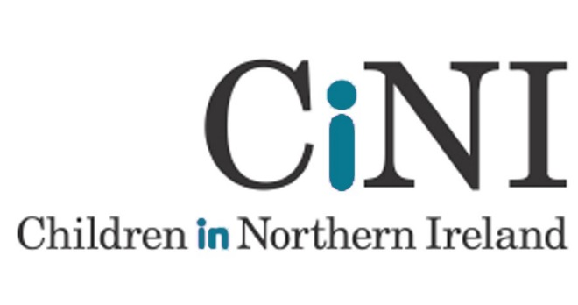

Dear Applicant

VOLUNTARY / COMMUNITY / BLACK MINORITY ETHNIC SECTOR REPRESENTATIVES ON OUTCOMES GROUPS

Children in Northern Ireland (CiNI) has been requested by the Health and Social Care Board to co-ordinate the recruitment process for community, voluntary and BME sector representatives on to the Outcomes Groups of the Children and Young People’s Strategic Partnership.

This round of recruitment relates to the five Outcomes Groups.

The purpose of Outcomes Groups is to share information, knowledge and expertise about the Outcomes Group area (which are co-terminus with the HSC Trusts areas), identify and remove barriers to more effective collaboration, build a commitment to early intervention, build an effective partnership, identify opportunities to pool budgets and make connections with other planning processes for children and young people. The Outcomes Groups report to the CYPSP.

The Membership of the Outcomes Groups is by application. The selection process will be in two stages. The first part of the process managed by Children in Northern Ireland and CYPSP staff will identify all applicants with the potential to contribute to the work of the Outcomes Groups. The second part of the process will see a list of eligible applicants passed to the Chairperson of the Outcomes Groups who will identify applicants best able to contribute to the work of the group. Those not selected will become part of a reserve panel open for the group for a period of three years

Please note that two terms will be the norm with a third term at the discretion of the Chair of the specific Outcomes Group.

All voluntary and community sector members who apply are recruited as individuals with knowledge of the sector and are not there to represent their own individual organisation. Individuals who move posts within the voluntary and community sector will not be required to leave the Outcomes Group. However, individuals who move from the voluntary and community sector to the statutory sector will be replaced by someone from the reserve panel.

Anyone selected to sit on the Outcomes Group can have one named substitute. Please also note that attendance will be recorded and set out in the annual report.

Please find enclosed the Nomination Form and a Person Specification. To make a nomination yourself, please complete the sections on the Person Specification and return it to:

Ellen Finlay, Children in Northern Ireland, Unit 9, 40 Montgomery Road,
Belfast, BT6 9HL or email ellen@ci-ni.org.uk
by 12 noon on Wednesday 14th September 2018.

Yours sincerely

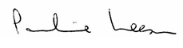

Pauline Leeson, CBE
Chief Executive

